Test of intervals in Bless You v.0.4(GF) of 2015-03-10.

Begränsat till första 100’000 samples om ej annat

??? Mkt 0:r i slutet???

Skall vara 2 sek. lång

Same as full:

Same as full: (but could not be fully read…)

Snapped:

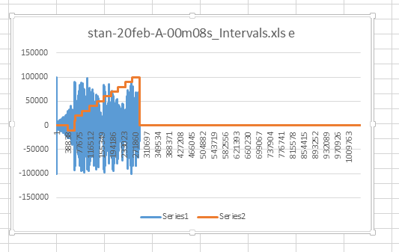

Same as full:

Same as full: